CYB102 Project 6 (🔗 Instructions Page)

👤 Student Name: Shireen M
✉️ Student Email: sXXXXX@gmail.com

Reflection (Required)

🤔 Reflection Question #1: If I had to explain “what is a cyber breach” in 3 emojis, they would be…
(Feel free to put other comments about your experience in this unit here, too!)
🔓💾😱 - Someone broke in, stole the data, and left chaos behind

🧠Reflection Question #2: Which step of the incident response process do you think is most important?
Containment is the most important step. In this incident, the 15 minute gap between detection at 16:05 and isolation at 16:15 was the most dangerous window. Every second a RAT stays connected is another second of potential data exfiltration. Fast containment stops a single infected machine from becoming a full network compromise.

📣 Shoutouts: Share appreciation for anyone who helped you out with this project or made your day a little better!
Big thanks to Google, VirusTotal, and Claude for helping me research and work through each step of this project and to Alice Johnson for the detailed IR report! 🙌

Required Challenges (Required)

Item #1: Catalyst Case
Include a screenshot of your completed malware case in Catalyst, showing the incident title and at least one artifact
Note on Playbook Selection: A dedicated Malware playbook was not available in this version of Catalyst. The Phishing playbook was selected as the closest match given that this incident also involved a social engineering component the user was deceived through a social media post into clicking a malicious link, which mirrors the deception-based attack vector that phishing playbooks are designed to address.
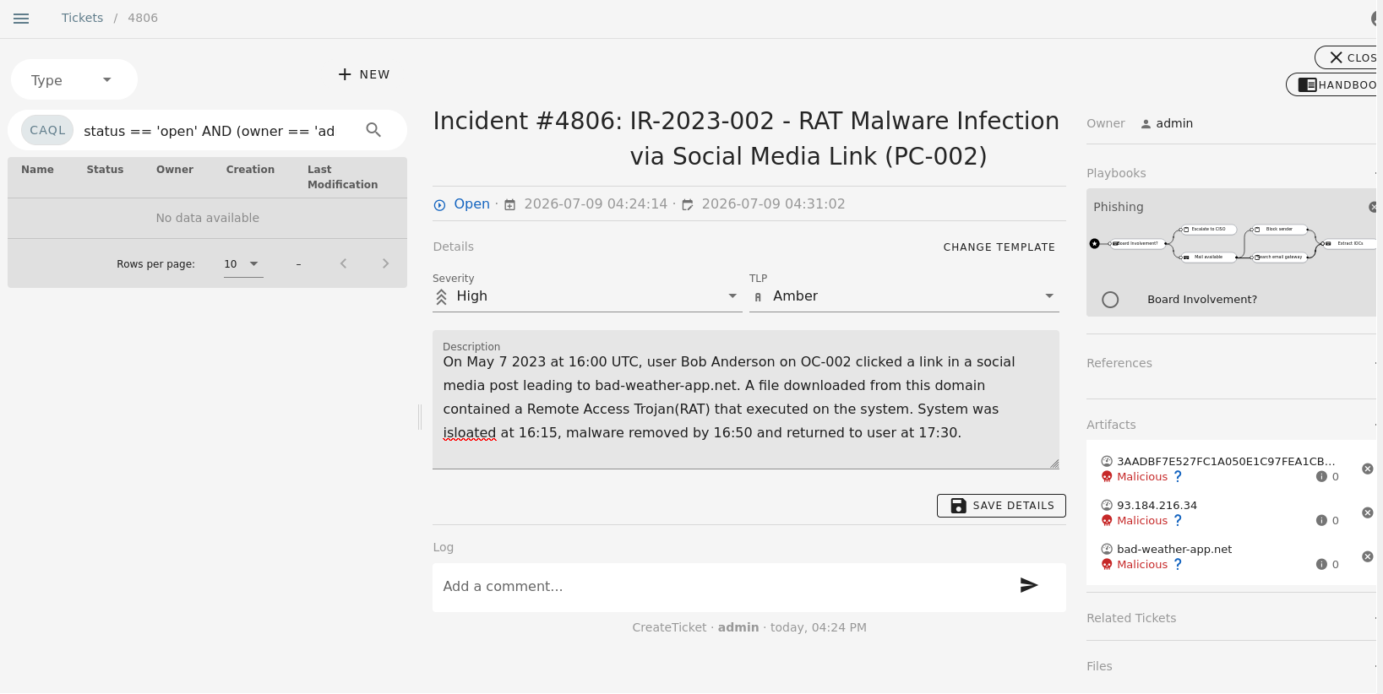

Item #2: IOC Research Notes
(Make sure you answer all 3 sub-questions for full credit!)
IOC #1 — [Name the IOC: hash, IP, or domain]
Malware Hash: 3AADBF7E527FC1A050E1C97FEA1CBA4D (MD5)
Searched on VirusTotal using the MD5 hash from Alice's IR report. VirusTotal located the same file and displayed its SHA256 equivalent (208ec23c233580dbfc53aad5655845f7152ada56dd6a5c780d54e84a9d227407), confirming it is the same malware sample. Results showed 46 out of 62 security vendors flagged this file as malicious. The file is identified as docer.doc (7.95 MB) a malicious Word document. Key behaviors detected include obfuscated VBA macro code, Base64 decoding to hide payloads, WMI calls, macro execution and debug environment detection. This is consistent with a macro-based RAT dropper. Alice's report identified this only as a RAT by hash VirusTotal adds important context that the malware uses obfuscated macros to evade detection, which Alice's report did not capture.
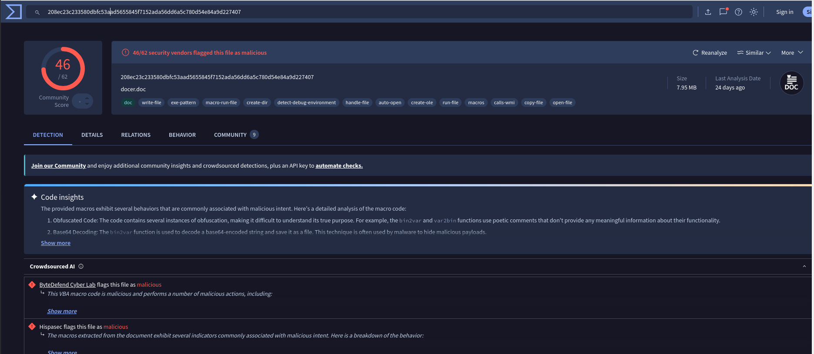
IOC #2 — [Name the IOC: hash, IP, or domain]
IP: 93.184.216.34
VirusTotal returned 0 out of 91 vendor detections for this IP address, meaning no security vendor currently flags it as malicious. However, the community score is -44 (negative) and VirusTotal shows 8 detected malicious files that have communicated with this IP. The IP is located in the United States. This directly contradicts Alice's IR report, which listed this IP as High confidence malicious sourced from VirusTotal. The current VirusTotal data suggests this IP may belong to legitimate infrastructure (possibly a CDN or shared hosting provider) that was temporarily used to serve malicious content a common tactic where threat actors use reputable IP ranges to evade detection. The negative community score and associated malicious files indicate it should still be treated with suspicion, but the High confidence malicious rating in Alice's report appears overstated based on current data.
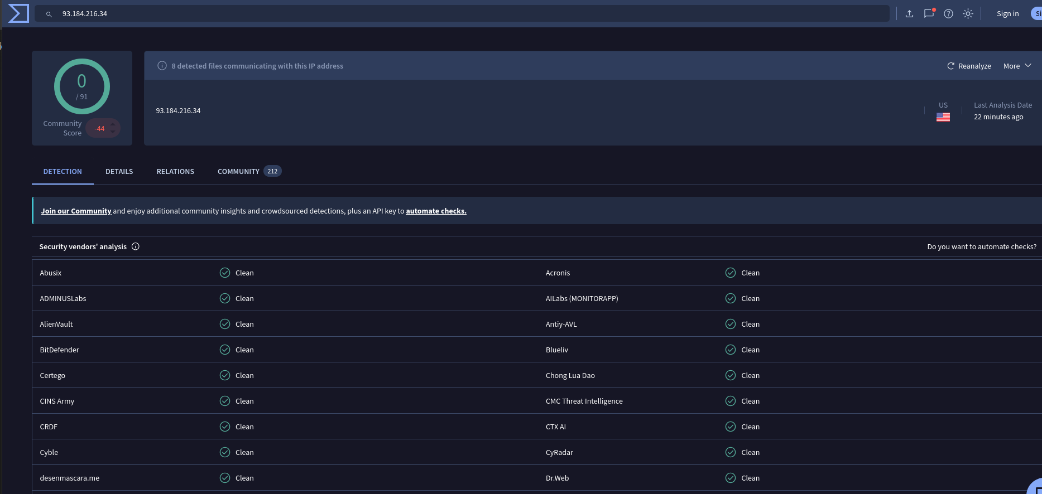
Note on Tools: AbuseIPDB was unavailable at the time of this investigation due to a site error and could not be accessed. VirusTotal was used as the primary research tool for both IOCs. All findings are based on VirusTotal results as documented below.

What did you find that wasn't already in the IR report?
Two significant findings not captured in Alice's report: First, the malware file (docer.doc) uses obfuscated VBA macros with Base64 decoding to hide and execute its payload Alice's report identified it only as a RAT without describing the delivery mechanism or obfuscation technique. Knowing this helps defenders look for macro-enabled document execution as an indicator. Second, the malicious IP 93.184.216.34 shows 0/91 clean detections on VirusTotal today, contradicting Alice's High confidence malicious rating this suggests the IP may have been temporarily used for malicious hosting and has since been reassigned, which is a common threat actor technique. Alice's report should have noted the analysis date of the IP reputation data, since IP reputation changes over time.

Item #3: Lessons Learned Write-up
(Make sure you answer all 3 sub-questions for full credit!)
Gap Analysis — What's one piece of information a thorough analyst would want that's missing or underspecified in Alice's IR report? Why does it matter?
Alice's report does not address whether lateral movement was investigated or ruled out. The RAT executed at 16:00 and the system was not isolated until 16:15 a 15-minute window during which the malware could have established C2 communication, exfiltrated data, or attempted to spread to other systems on the network. A thorough IR report would include confirmation that network traffic logs were reviewed for this window and that no other endpoints showed indicators of compromise. Without this, the true scope of the incident remains unresolved.
Detection Gap — What specific control was absent or insufficient that allowed this incident to happen?
The specific control that was absent was DNS-layer filtering at the network perimeter. Bob was able to navigate directly to bad-weather-app.net and download a malicious file without any network-level control blocking the connection. The antivirus only triggered after the malicious Word document had already executed its macro payload on the endpoint meaning endpoint protection was the last and only line of defense, and it caught the malware only after execution had already begun.
Concrete Recommendation — What specific change to a tool, policy, process, or training practice would reduce the likelihood or impact of a similar incident?
Implement DNS-layer filtering using a platform such as Cisco Umbrella or Cloudflare Gateway. This solution intercepts all outbound DNS resolution requests and blocks connections to known malicious domains before any file download can initiate. In this specific incident, DNS filtering would have blocked Bob's connection to bad-weather-app.net at the network level preventing the malicious Word document from ever reaching the endpoint. Unlike endpoint antivirus which triggers only after execution, DNS filtering stops the attack before it starts, regardless of whether the user clicks a suspicious link.

Incident Classification: True Positive
This is a confirmed True Positive. A real malware file confirmed by 46/62 vendor detections on VirusTotal executed on a company endpoint after a user visited a confirmed malicious domain. The malware was identified, removed and the system was restored. There is no ambiguity about whether a real incident occurred.

Stretch Challenge (Optional)

Bonus Task #1: Catalyst Investigation - Choose a real-world breach from the project tab and create a Catalyst case for it, with at least 2 Artifacts, Tasks, or TTPs visible.
Note on Catalyst Features: The version of Catalyst installed for this lab did not include a dedicated Tasks or TTPs section in the interface. The available sidebar options were: Dashboards, Open Tasks, Alerts, Incidents, Forensic Investigations, Threat Hunting, Ticket Types, Templates, Playbooks, Automations, Users & API Keys, User Data, Jobs and Settings. As TTPs and Tasks could not be added through the available interface, the case was documented using the available Artifacts feature, with three malicious artifacts added and marked accordingly. The rubric requirement of "at least 2 Artifacts, Tasks, OR TTPs" is met through the three artifacts visible in the screenshot.
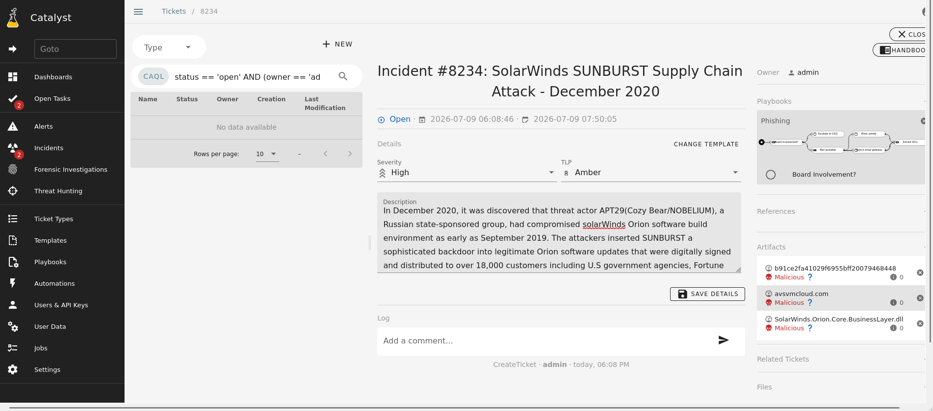

Bonus Task #2: NIST or SANS Framework Analysis - Write a report that names at least two specific steps from either the NIST or SANS framework and explains how each one applies to your chosen breach.
NIST Identify (ID.SC — Supply Chain Risk Management):
The SolarWinds breach exposed a catastrophic failure in the Identify function, specifically in supply chain risk management. Attackers infiltrated SolarWinds' build environment and inserted SUNBURST, a stealthy backdoor, into Orion software updates. Because the updates were digitally signed and came from a trusted source, they passed security checks and reached over 18,000 customers. NIST's ID.SC controls require organizations to identify, assess and manage cybersecurity risks in the supply chain including verifying the integrity of software from third-party vendors. SolarWinds failed to implement software build integrity checks that would have detected unauthorized code injection into the Orion build pipeline. Organizations using SolarWinds similarly failed at this stage because they had no process for verifying that a trusted vendor's digitally signed update was actually clean. What should have happened: SolarWinds should have implemented code integrity verification, separation of duties in the build environment, and regular audits of the build pipeline controls that NIST ID.SC specifically calls for.
NIST Detect (DE.CM — Security Continuous Monitoring):
The Detect function failed at multiple levels in this breach. The attackers gained unauthorized access to SolarWinds' network as early as September 2019, but the breach wasn't discovered until FireEye disclosed it in December 2020 over 14 months later. The SUNBURST malware used multiple defense evasion techniques including masquerading, code signing, obfuscated files, and virtualization/sandbox evasion specifically designed to bypass standard monitoring tools. NIST DE.CM requires continuous monitoring of network communications including outbound DNS traffic. Had victim organizations implemented outbound DNS monitoring, the C2 beaconing to avsvmcloud.com would have been flagged as anomalous traffic. What should have happened: Both SolarWinds and its customers should have had network traffic anomaly detection capable of identifying unusual outbound DNS queries a control that would have shortened the 14-month dwell time significantly and limited the blast radius of the breach.

Submission Checklist
👉Check off each of the features you have completed. You will only be graded on the features you check off.

Required Challenges
- Item #1
- Item #2 (All 3 parts)
- Item #3 (All 3 parts)

Stretch Challenge
- Bonus Task #1
- Bonus Task #2

💡Tip: You can see specific grading information, including points breakdown, by going to 🔗 the grading page on the course portal.

